Flight Finder: Navigating Your Air Travel Options

Project Documentation

- Introduction
Project Title: FlightFinder: Navigating Your Air Travel Options
Team Members:
Team Leader : Garikipati Tripura
Team member :Moparthi Charitha
Team member : Pamarthi Vigna Sesha Manikanta
Team member : Seera Krishna Sai
2.Project Overview
Purpose: FlightFinder is a full-stack web-based flight booking system developed using the MERN stack (MongoDB, Express.js, React.js, Node.js). The primary goal is to provide users with a secure and efficient platform to search, book, and manage flights while allowing administrators to manage flight data through a dedicated dashboard.
Features:
The FlightFinder platform includes the following key features:
- User Authentication:
Secure user registration and login using bcrypt password encryption.
- Flight Search:
Users can search flights based on departure city, destination, and travel date.
- Flight Booking:
Users can book available flights and receive booking confirmation.
- Booking Management:
Users can view booking history and cancel reservations.
- Admin Dashboard:
Admins can add, update, and delete flights, and monitor bookings.

3. Architecture
The FlightFinder application follows a 3-tier MERN architecture, separating frontend, backend, and database layers.
.User Interface Layer (React.js):Handles user interaction including login, flight search, booking, and admin dashboard.

.Application Layer (Node.js & Express.js):Processes API requests, manages authentication, handles booking logic, and interacts with the database.

.Data Layer (MongoDB)
Stores collections for Users, Flights, and Bookings using Mongoose schemas
Architectural Diagram:
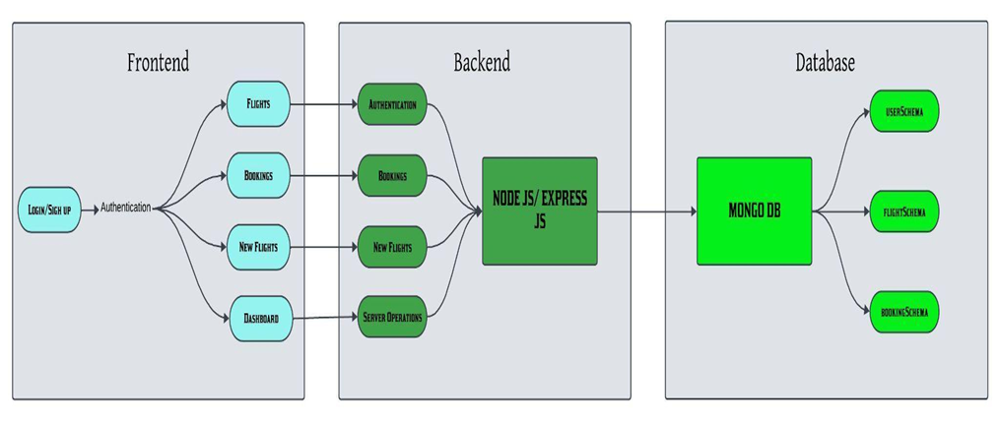
4. Setup Instructions
Prerequisites:
- Node.js:Node.js (v16 or higher) must be installed to run the backend server.
- npm: Node Package Manager (comes with Node.js) to install project dependencies
- MongoDB: MongoDB (Local or MongoDB Atlas) for storing user, flight, and booking data.
- React.js: For building the frontend user interface.
- Express.js: For handling backend routing and API development.
- Mongoose: For connecting Node.js with MongoDB and performing CRUD operations.
- bcrypt: For secure password encryption.
- Code Editor: Visual Studio Code or any preferred IDE.
- Git: For Version Control
Installation:
- Clone the Repository:git clone <your-repository-link>
- Navigate to Project Directory:cd Flight-Booking-app
- Backend Setup:
- Navigate to server folder:cd server
- Set Up Environment Variables (.env file):
Create a file named .env inside the server folder.
o Add the following lines to your .env file, replacing the placeholder with your actual MongoDB connection string:
- MONGO_URI="YOUR_MONGODB_CONNECTION_STRING"
- PORT=6001
- Start the Backend Server: npm start
- Frontend Setup:
- Navigate to client folder:cd client
- Start the React Application:npm start
  - Ensure there are no spaces around the = sign and values are in double quotes. This securely manages your API credentials.
5. Folder Structure
- Flight Booking app/
- │
- ├── client/ → React frontend
- ├── server/ → Node.js + Express backend
- ├── .vscode/ → VS Code settings
- Client Folder(Frontend):contains React components,pages,Css styling
- .env: Contains environment variables for API keys and URLs.
- Server Folder(Backend):contains Express server configuration,Routefiles,Mongoose schemas,Authentication logic,Database Connection
Running the Application
To run the FlightFinder application locally:
- Open your terminal or command prompt.
- Navigate to the project's root directory (FlightFinder): D:\Mernstack/Flight Booking app>
- Backend runs on:http://localhost:6001
- Frontend runs on:http://localhost:3000
6. API Documentation
The backend exposes RESTful APIs:
Authentication APIs:
- POST /api/register
- POST /api/login
Flight APIs:
· GET /api/flights
· POST /api/flights (Admin)
· PUT /api/flights/:id (Admin)
· DELETE /api/flights/:id (Admin)
Booking APIs:
· POST /api/bookings
· GET /api/bookings/:userId
· DELETE /api/bookings/:id
7.Authentication: Authentication is implemented using:
bcrypt for password hashing
Role-based access (User/Admin)
Protected routes for admin operations
Passwords are encrypted before storing in MongoDB.
8. User Interface
The UI is built using React.js with responsive design.
❖ Main Application Layout:
· Navigation bar
· Login/Register pages
· Flight search interface
· Booking history page
· Admin dashboard
❖ Dynamic Data Handling
Axios for API requests
Real-time flight listing
Booking confirmation updates
9. Testing
The project's testing strategy involves:

Functional Testing

Login validation
Flight search accuracy
Booking storage verification
Admin CRUD operations

- Integration Testing:
· Frontend-backend API communication
· Database updates after booking

- Integration Testing:
· Frontend-backend API communication
· Database updates after booking
- Error Handling:
· Invalid login credentials
· Missing search inputs
· Database connection errors
10.Screenshots:
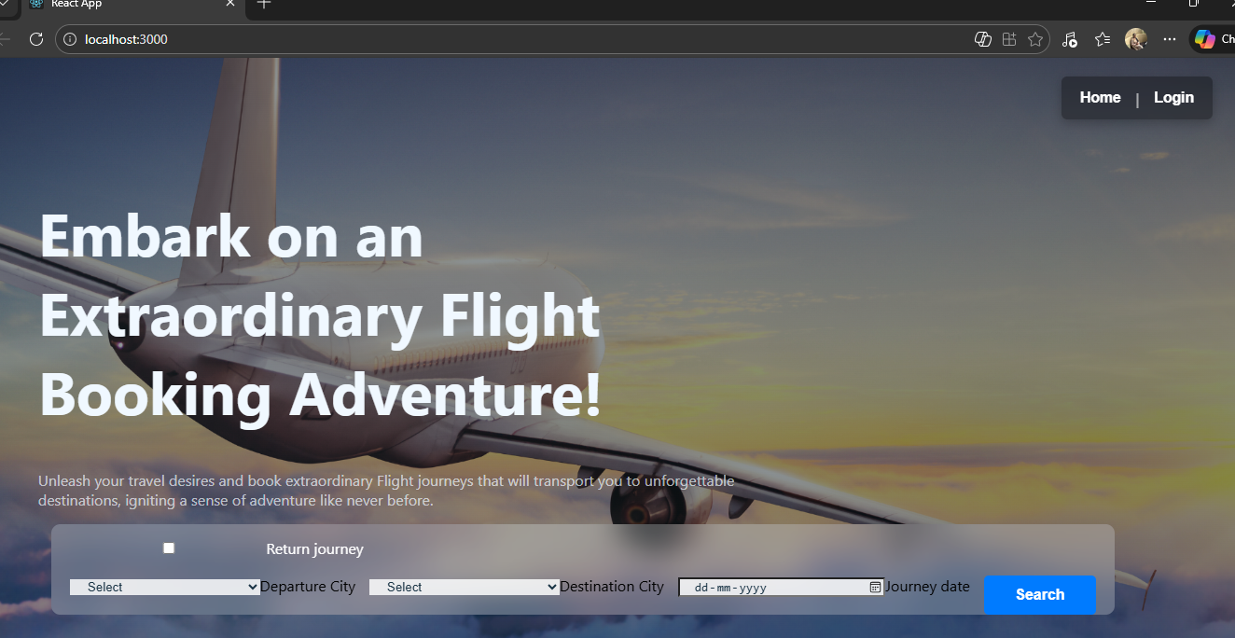
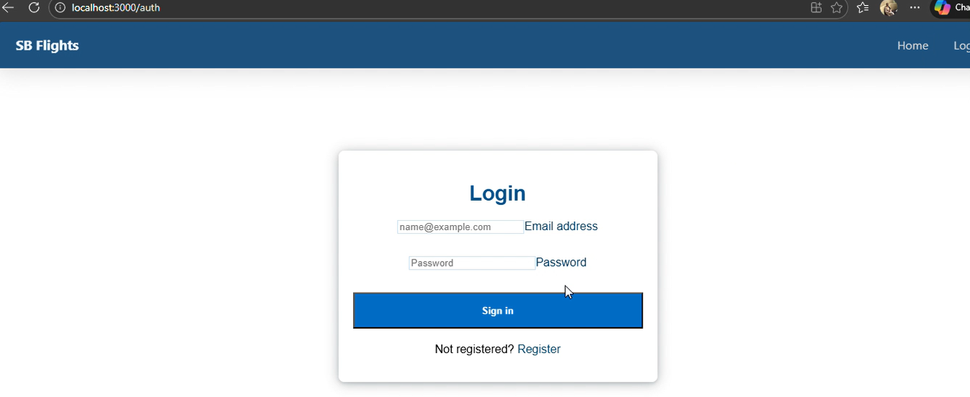

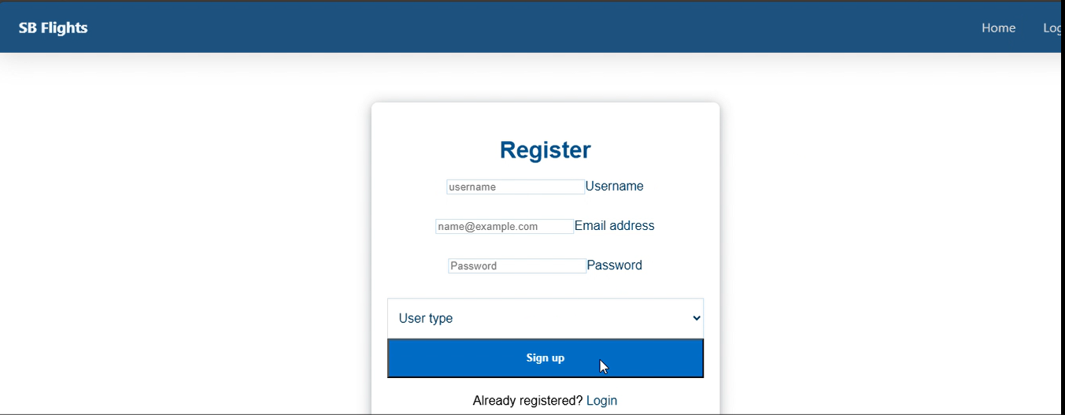
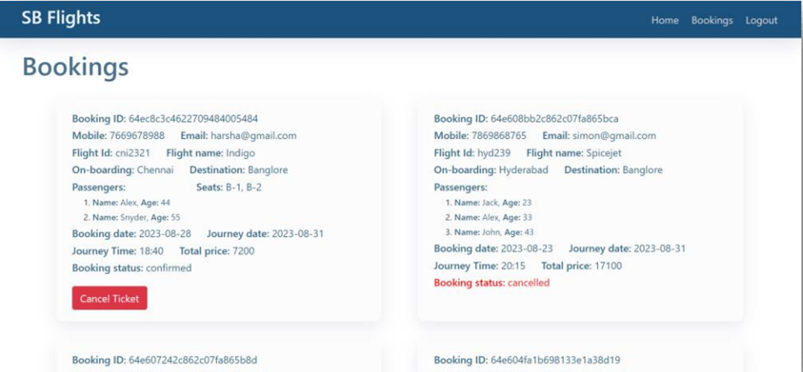
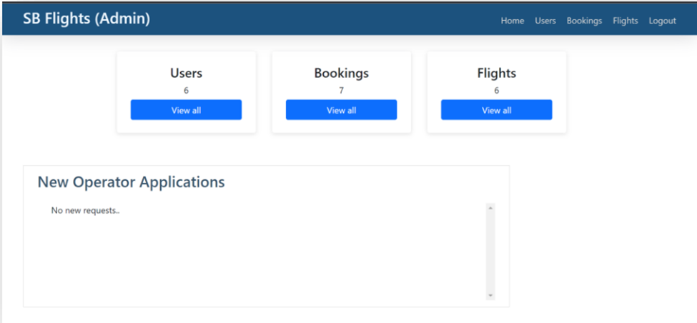
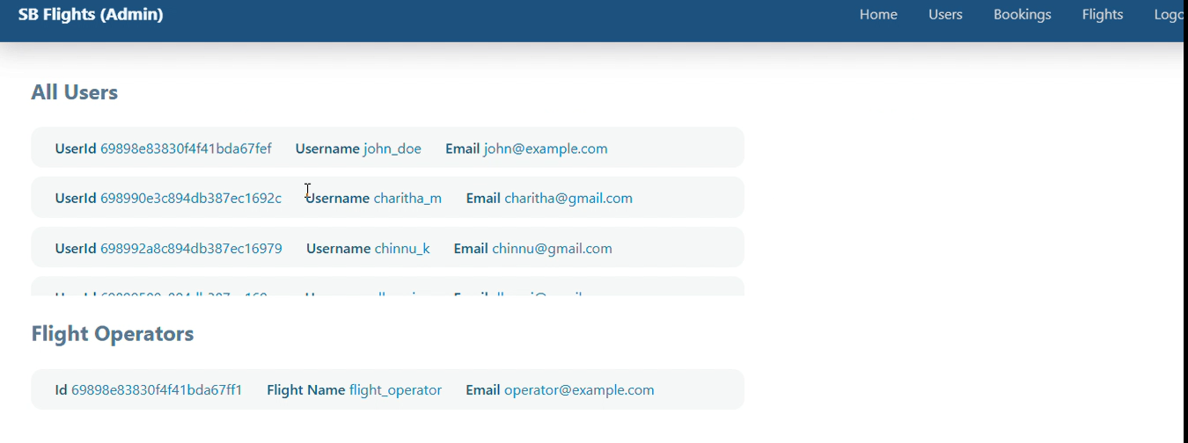
11. Future Enhancements
· Integrate real-time airline APIs
· Add payment gateway (Razorpay/Stripe)
· Deploy to cloud (AWS/Render/Vercel)
· Add JWT-based authentication
· Implement seat availability tracking
· Improve UI with advanced filtering

